
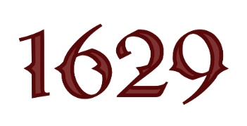
Welcome Valued 1629 Wine Club Members. Thank you for joining us this evening!

Starters

Charcuterie Board - $23
House selection of fresh cut meats, cheese and house-made crostini

Caesar Salad -$12
House-Made Dressing with Croutons

Blistered Shishito Peppers- $13
Lemon Garlic Aioli

Bruschetta $9
Soup Du Jour-$8
Lobster Bisque

Shrimp Cocktail - $12
House-Made Cocktail Sauce

Pomegranate Seed,Brie and Cranberry

Wood Fired Brick Oven Pizzas $23

Toscana Pizza
Mozzarella , sausage, salami and ham
Bee Sting Pizza
Pepperoni, Honey Pepper Flakes

Funghi Pizza
White pizza, fresh mozzarella, mushrooms, truffle oil

Pair your pizza with a glass of 2022 Rose

Dinner Specials

Seafood Special-$28
Champagne sauce with Shrimp and Pasta
Pair with 2019 La Copine

Filet Mignon-$38
Filet Mignon with Demi, Asparagus and Mash
Pair with 2019 Meritage

Chicken Tikka-$32
Basmati Rice and Pita
Pair with 2022 Viognier

