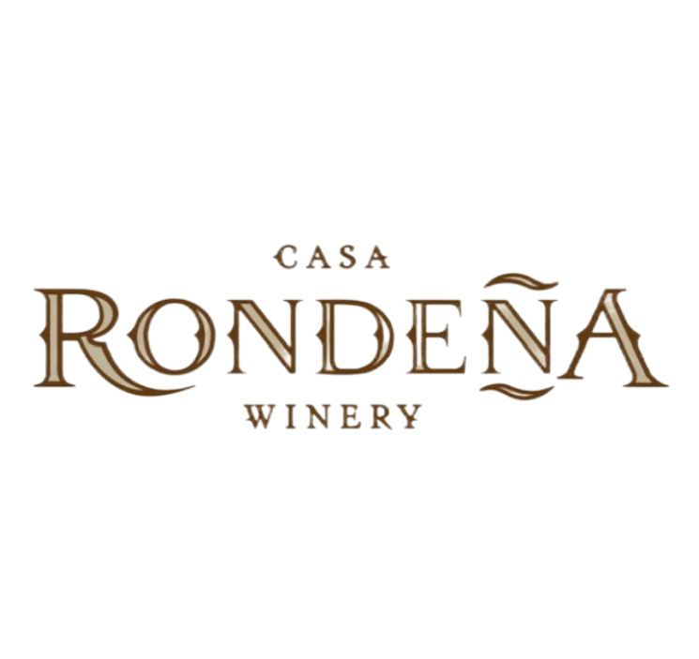
Happy Hour
Monday–Friday | 4-6pm
$2 off a glass of wine or a wine flight.
By the Glass By the Bottle
White
2024 Viognier $12 $29
A blend of New Mexico and Colorado Viognier grapes. Wonderful aromas, tropical fruits, and hints of honey, melon, banana and ripe patches.

2024 Shining River $12 $28
Dry, crisp, clean. Ripe melon, honeysuckle, passion fruit. The Rio Grande under the bright sun of New Mexico…Our home, and the reason for being here. Vintner’s Favorite. 77% Aromella, 23% Viognier

Rosé
Animante Sparkling Rosé $12 $42
Elegant and refreshing, this sparkling rosé blends 85% Chardonnay and 15% Pinot Noir, offering delicate notes of strawberry and citrus, enlivened by fine bubbles and a crisp, clean finish.

2024 Merlot Rosé $12 $30
Enchants from the first glass. Flavors of wild strawberries and cherries unfold with a gentle touch, balanced by a graceful, lingering finish. Light, lovely, and effortlessly charming. This wine is made for shared moments and stolen glances.

Red
2024 La Copine $12 $31
A light, gentle low tannin table wine. La Copine reminds us of our feminine nature and our lightness of being. Beaujolais in style, great on a sunny afternoon or by the fireside amongst the rustling Autumn leaves. Merlot and Viognier.

2022 Cabernet Franc $12 $42
It’s been a quarter century since Casa Rondeña produced its first Cabernet Franc. Along the way, we’ve learned a few things. Classically varietal: earth tones, briarwood, dark fruit, forest floor, high desert sun.

2022 Meritage $12 $38
A Bordeaux style blend of Cabernet Franc, Merlot, and Cabernet Sauvignon. Slightly pungent and earthy, it delivers a wide range of red fruit, plum, boysenberry, black pepper and spice, with silk tannins and jam, as well as darker fruits in the finish. Old World in style and a
Casa Rondeña best-seller for over a quarter century!

2023 1629 $13 $45
This John Calvin creation is Iberian in style, a reflection of a passion for the high desert climate it represents. A blend of Tempranillo, Syrah, and Cabernet Sauvignon, it is deep, rich, pungent and balanced with notes of dark fruit. Drink with someone you love.

2022 Syrah $13 $48
A very rich, luscious, and smooth deep red wine with blackberry and black cherry notes. Aged for 24 months in oak barrels, this vintage is full-bodied and also features notes of plum, smoke, and white pepper spice with a dry finish.

Port
Animante $14 $36
A deep, rich, tantalizing, robust, and decadent port-style wine that pairs beautifully with rich desserts, such as chocolates. We have a deep regard for Port wines and the history surrounding them. We bring you this extremely special and limited offering – which our winemaker, John Calvin, says is the best vintage crafted over the last generation – to complete any holiday celebration!

Tasting Room | Open Daily from 12pm-7pm
Casa Rondeña Winery | 733 Chavez Road NW | Los Ranchos de Albuquerque, NM 87107 | 505.344.5911

