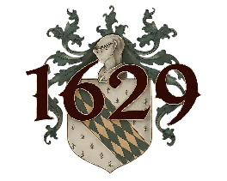
V I N O S
Estate Wines of Casa Rondeña
——————————————
T I N T O S
Red Wines
—— ✦ ——
1629
Our flagship blend. Tempranillo, Syrah, and Cabernet Sauvignon. Complex, full-bodied, with notes of plum and dark berries.
Glass $14 · Bottle $38
Cabernet Franc
Earth tones, briarwood, dark fruit, forest floor, and high desert sun. A quarter century in the making.
Glass $14 · Bottle $38
Syrah
Full-bodied, aged two years in fine French oak. Soft tannins, rich, earthy, and luscious.
Glass $16 · Bottle $46
Meritage
A classic Bordeaux-style red blend. Rich, layered, and refined.
Glass $14 · Bottle $38
La Copine
70% Merlot, 30% Viognier. A bold and unexpected union of dark berry richness and floral aromatics.
Glass $14 · Bottle $38
B L A N C O S
White Wines
—— ✦ ——
Viognier
Dry and aromatic with stone fruit, honeysuckle, and a mineral finish.
Glass $12 · Bottle $32
Shining River
Refreshing white with hints of honeysuckle. Light, inviting, and perfect for a warm afternoon.
Glass $12 · Bottle $32
R O S A D O
Sparkling
—— ✦ ——
Sparkling Rosé
85% Chardonnay, 15% Pinot Noir. Delicate and effervescent with notes of fresh strawberry and crisp minerality.
Glass $14 · Bottle $38
V I N O D E P O S T R E
Dessert Wine
—— ✦ ——
Animante
Graceful and decadent port-style wine, aged in French and American oak. Rich notes of chocolate and plum.
Glass $16 · Bottle $46

